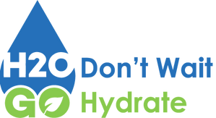
H2OGO Program
Terms & Conditions
Available Locations
Currently the H2OGO Program is available on every floor in the following locations:
- Appalachian Heights
- Belk Hall
- Cannon Hall
- Cone Hall
- Dogwood Hall
- Doughton Hall
- Elkstone Hall
- Frank Hall
- Laurel Creek Hall
- Living Learning Center (LLC)
- Mountain Laurel Hall
- Mountaineer Hall
- Newland Hall
- New River Hall
- Raven Rocks
- Summit Hall
- Thunder Hill
- White Hall
- Student Union

